# freETarget

Application Note:

Building a Five Bay Rapid Fire Target

**CAUTION**

|  |
| --- |
| When using freeTarget:   * Wear eye protection * Maintain a safe distance * Do not shoot into any areas except the open target areas.   The freeETarget project or contributors will not be responsible for any injuries when using this target of it’s components.  Target shooting can be dangerous so apply caution in everything you do. |

**SUMMARY**

This application note describes how to merge five targets into a single five bull rapid fire target.

* Joining five targets
* Configuration
* Use
* Bill of Materials

**INTRODUCTION**

Conventional operation of freETarget is one shooter, one target. In rapid fire, the user uses five separate targets and puts one shot into each. The results are then merged into a single score.

Five freeTargets can be linked together so that the scores in each is relayed back to a central target and then on to the client PC. This allows for five targets to be controlled and monitored from one place. The setup is illustrated in Figure 1.

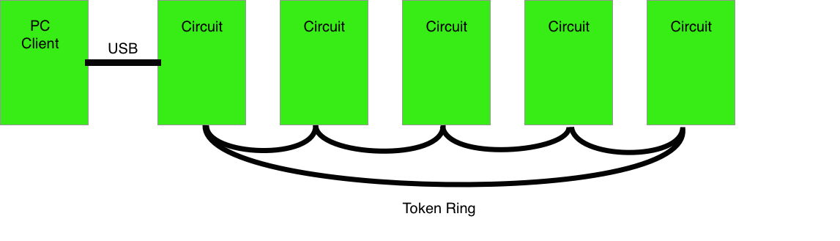

Figure 1: Rapid Fire Assembly

As each shot is fired, the score is passed along to the next circuit in the loop until the message arrives at the central PC and the messages is sent along to the PC client. The PC client then adds the new score to the previous accumulation.

**ASSEMBLY**

The first part of the assembly is to build five conventional targets, just the same as any other air pistol target. You can elect to paint the front of the targets with a large black circle to emulate the appearance of a standard rapid fire target

**Wiring**

The trick to the rapid fire target is the token ring network linking the five targets back to the PC. The token ring cable is illustrated in Figure 2.

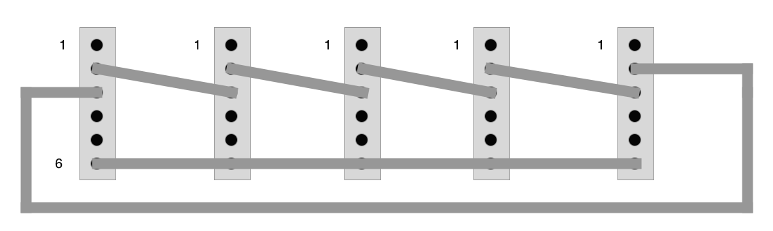

Figure 2: Token Ring Cable

The Token Ring cable connects the transmit of one circuit to the receive of the next until the ring is complete. A shot record sent from any of the circuits will circulate to the next until it reaches the circuit connected to the PC and the shot is relayed onto the PC.

The token ring cable attaches to the AUX connector (J12) on the Arduino shield. Please note that the WiFi and Token Ring cannot be used together, and communication to the PC is from the master circuit.

**Settings**

The rapid fire software is available on any firmware 4.2 and higher. To use the rapid fire option make sure that your software is up-to-date. After that you will need to enable the token ring

From the Arduino tab, set

{“TOKEN”:1}. This circuit is attached to the PC client

{“TOKEN””2}. This circuit is part of the ring and not connected to the PC directly.

Setting {“TOKEN”:0} will remove the token ring software and go back to WiFi